1. **Web API:**  here we only need model and controllers.
2. **Razor Pages:** here there is no MVC, we simply have the pages (a cshtml file and for each file a .cs file),
3. **MVC:** here we have model, view and controller.

We use the ConfigureServices() method to configure to any of the architecture.

**MVC:**

* Old way,

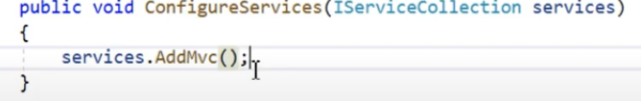

* New way, 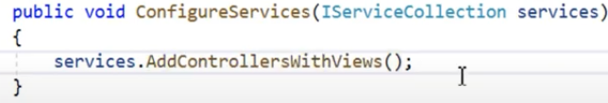

**Web API:**

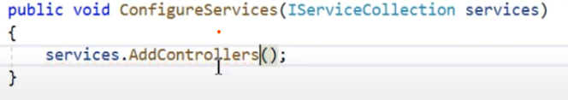

**Razor Pages**

